

**Experimental Lab Student Report**

Week 5 Lab

Lab Title: Files and File Attributes

Student Name: Anthony Meunier

Date: 2/6/2014

After completing the activities, take a screenshot of the following and copy onto this report:

1. Activity 7-1, after #3 (7 points)

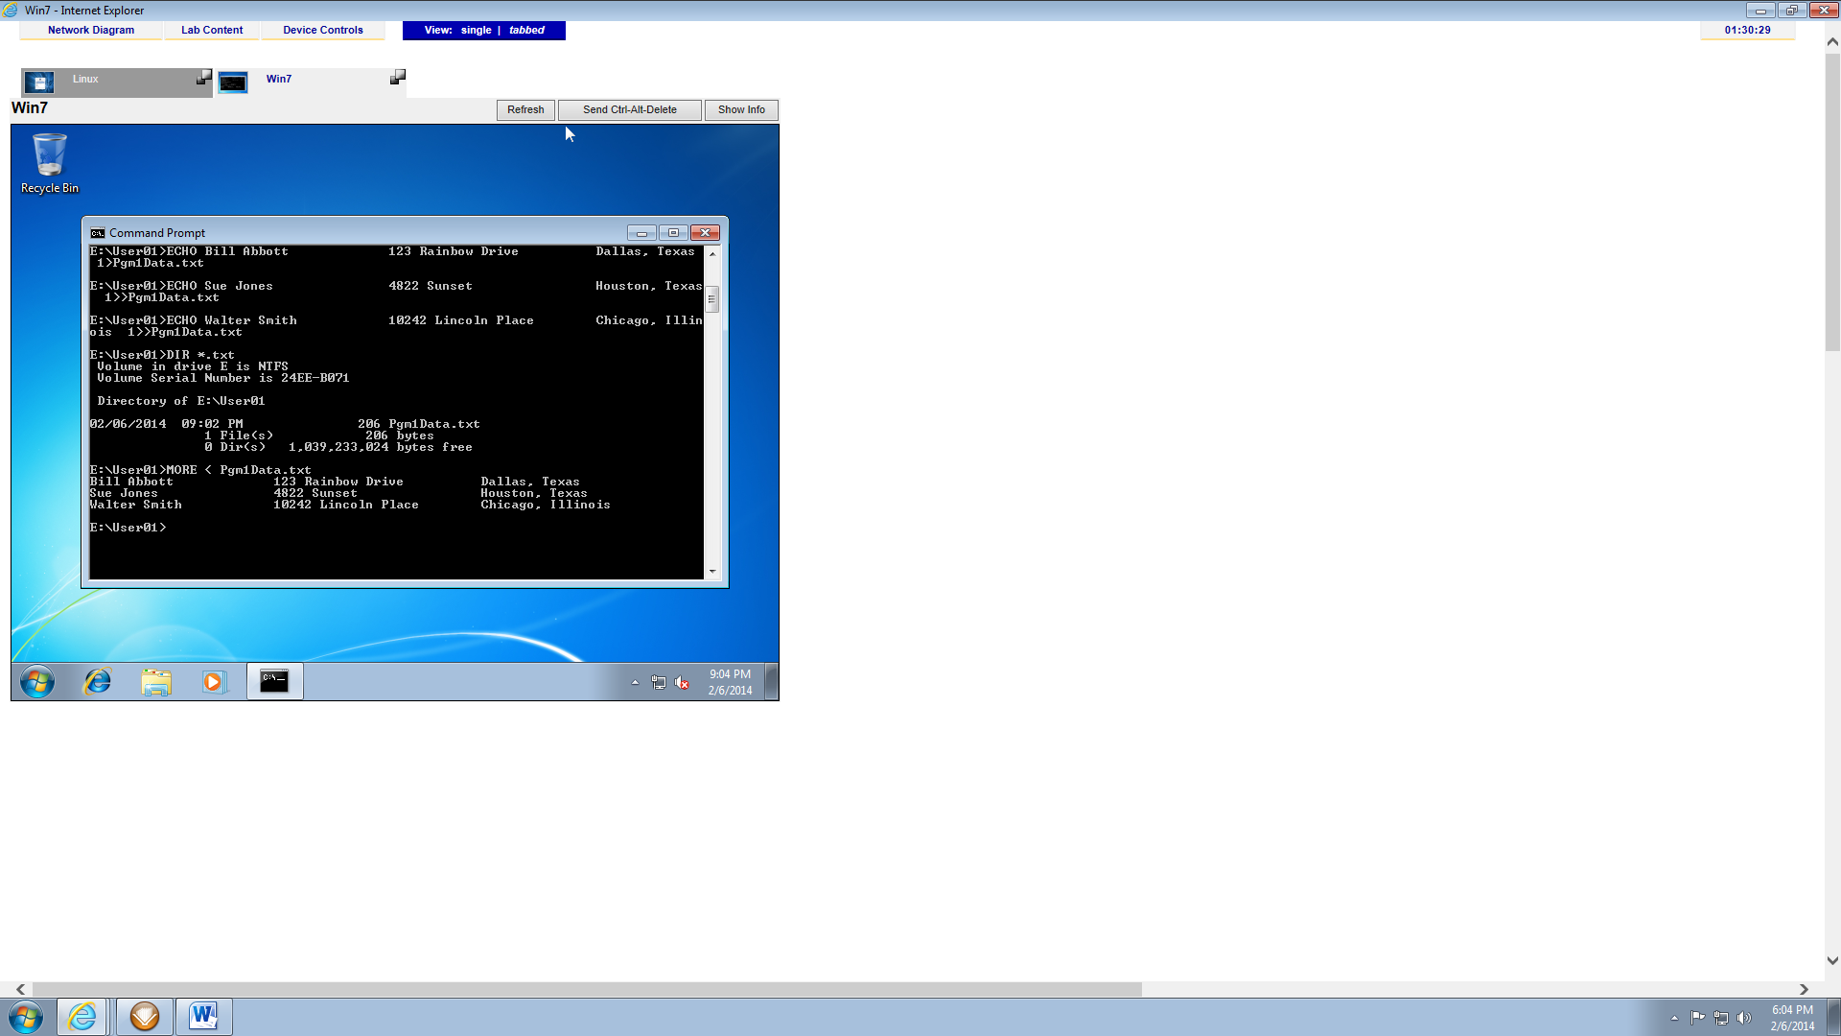

1. Activity 7-2 (7 points)

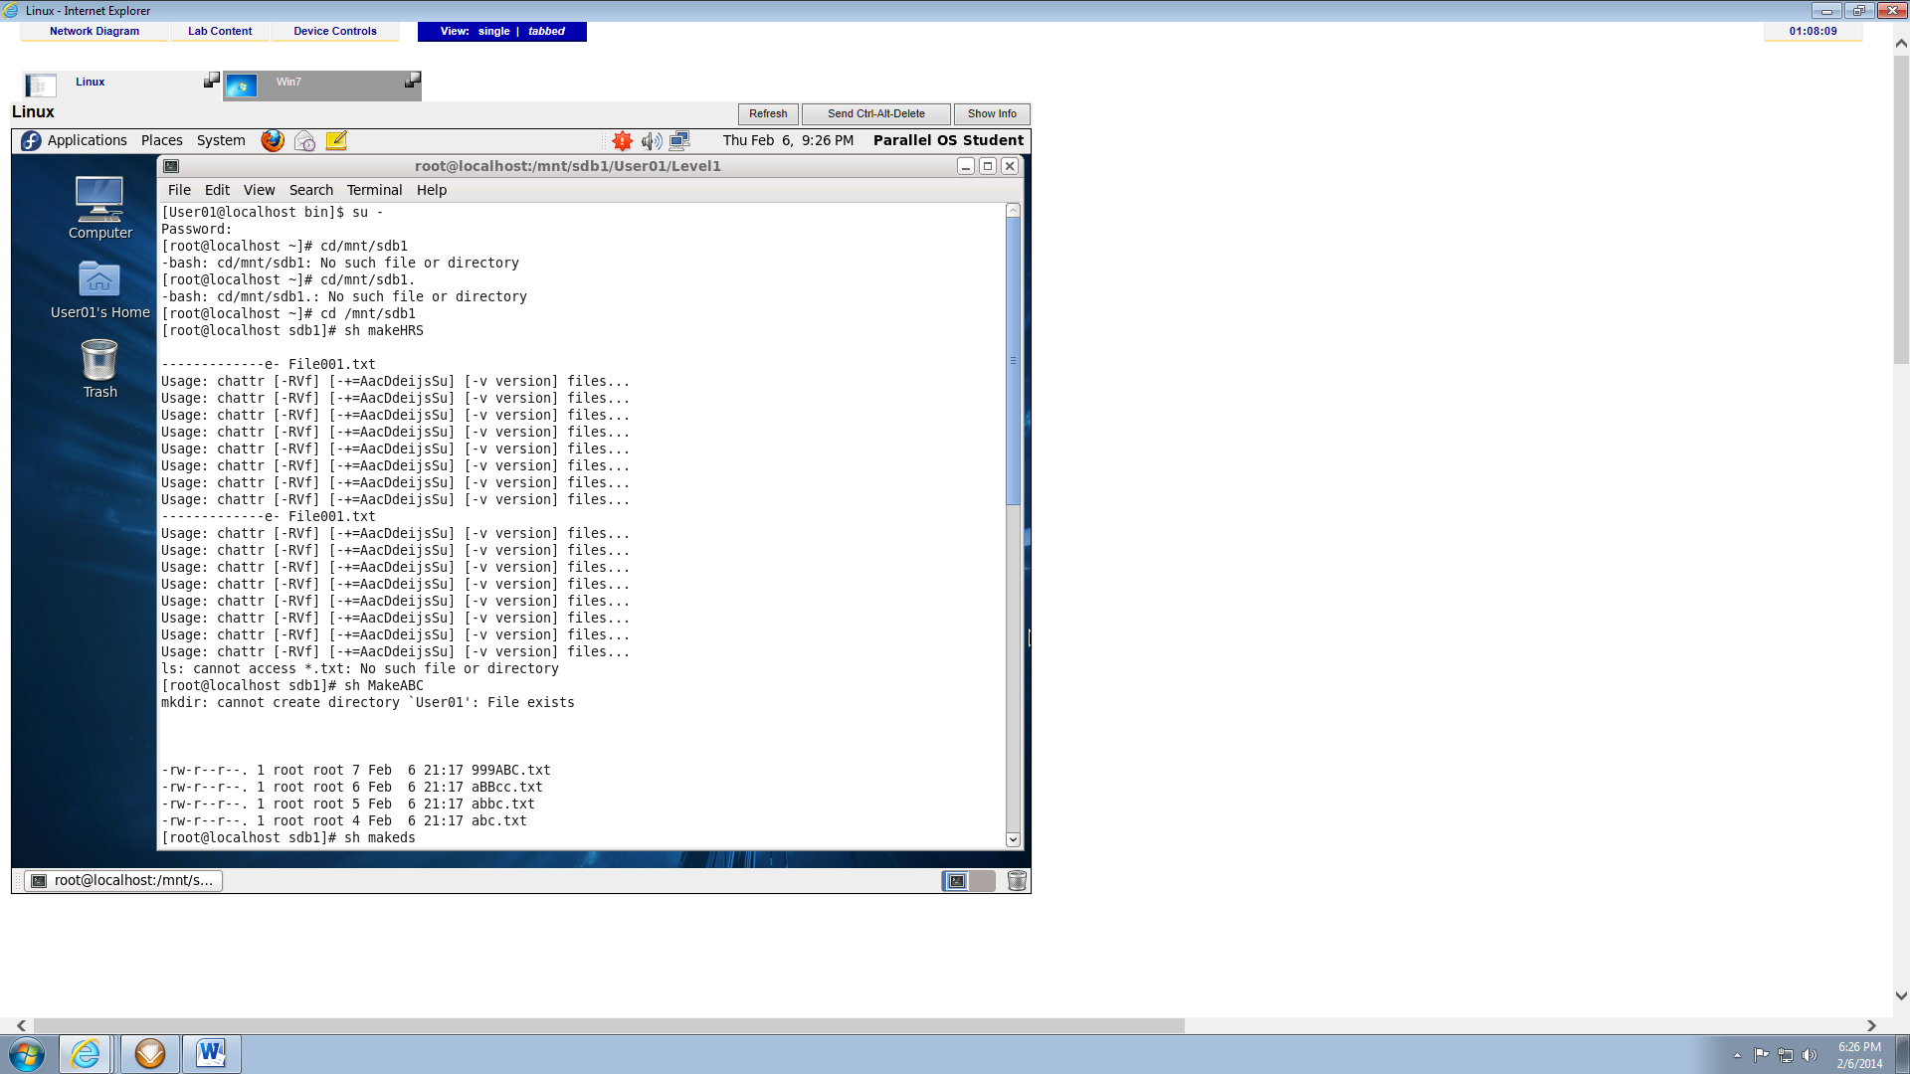

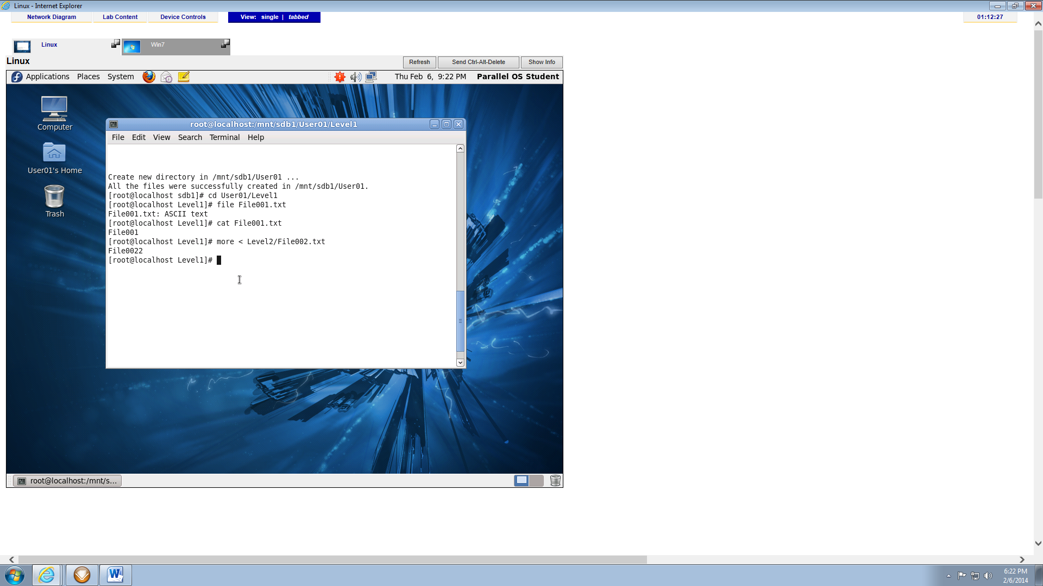

1. Activity 7-7, after #10. (7 points)

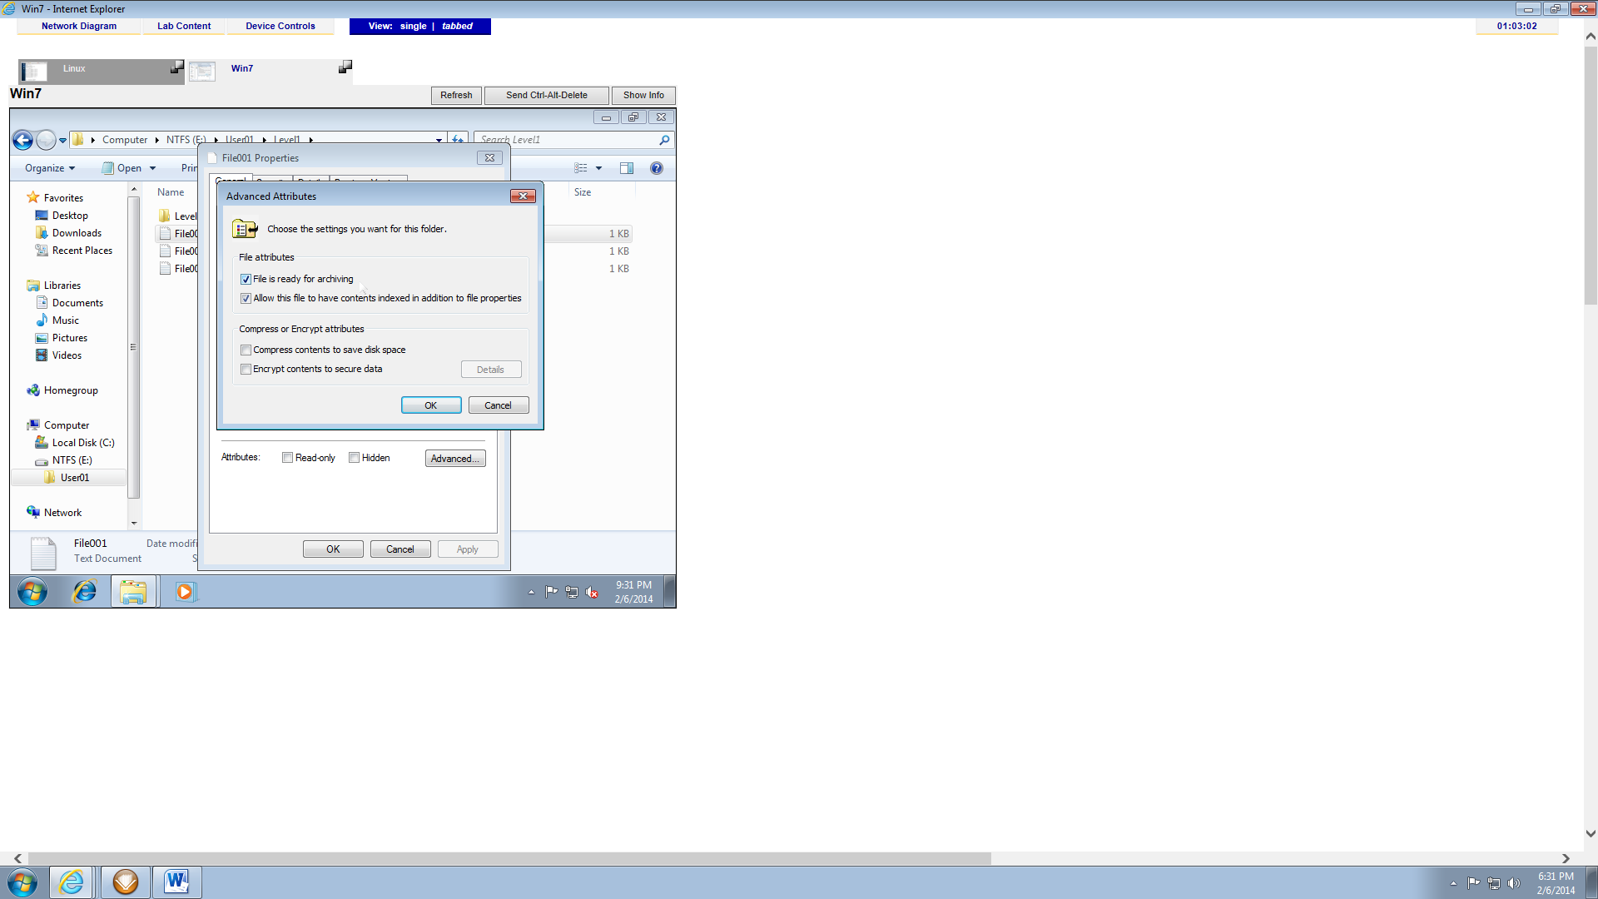

1. Activity 7-7, after #14 (7 points)

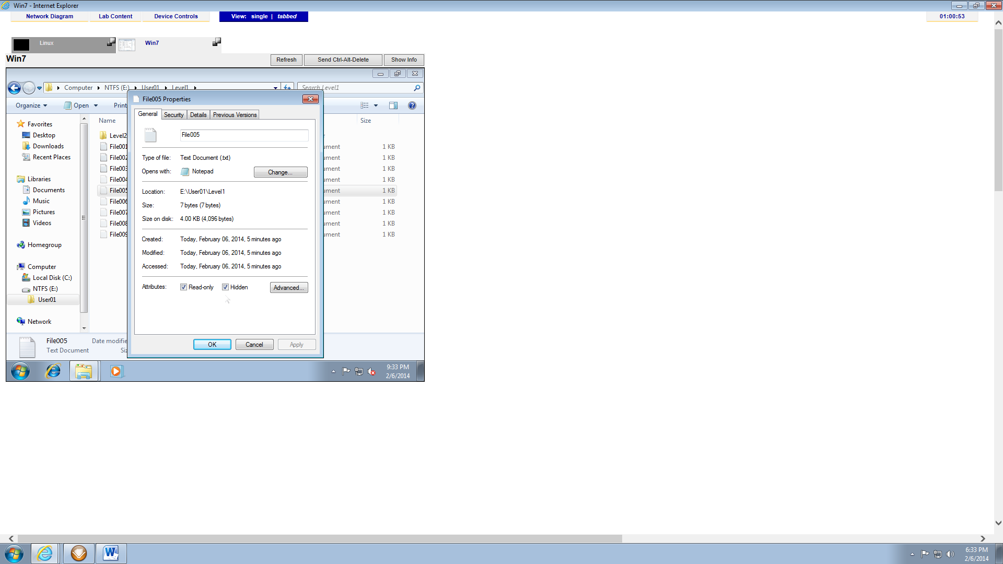

1. Activity 7-10, after ls –l, ls –la, and lsattr (7 points)

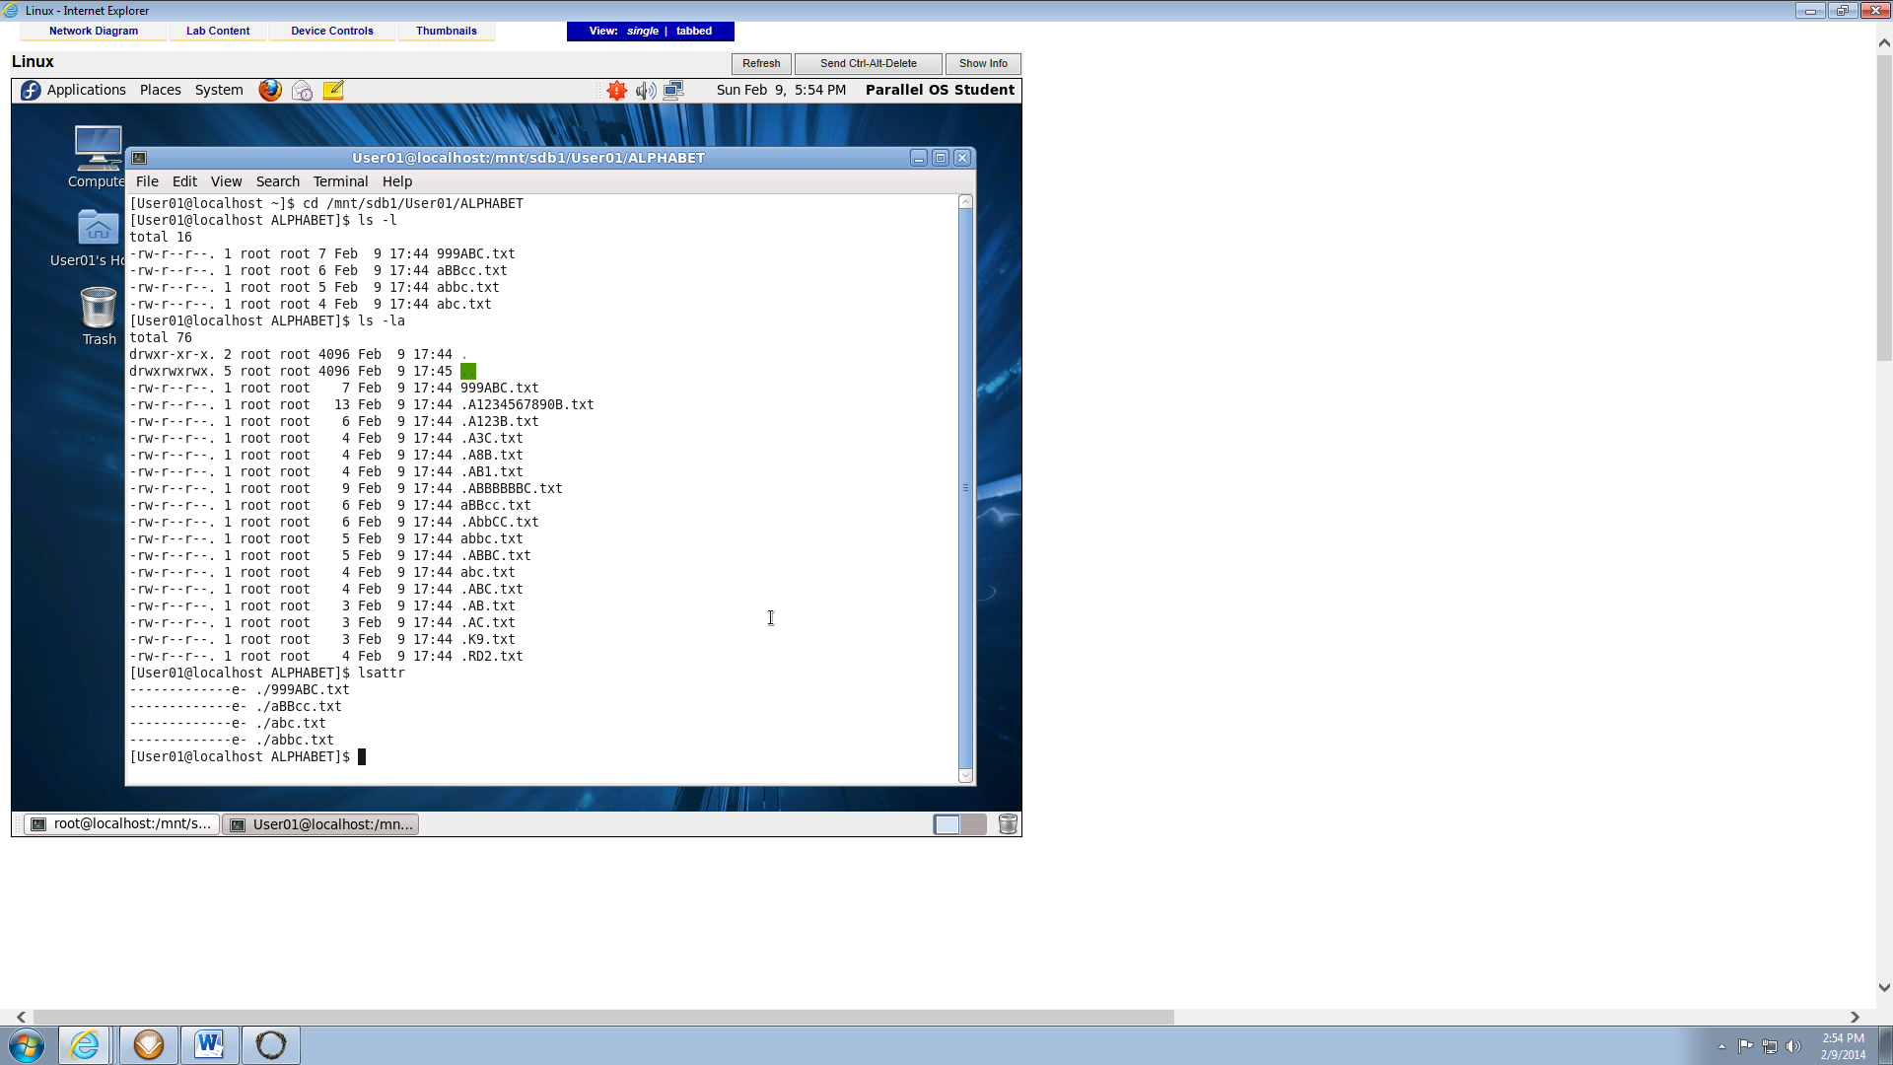

1. Activity 7-16, after #7 (7 points)

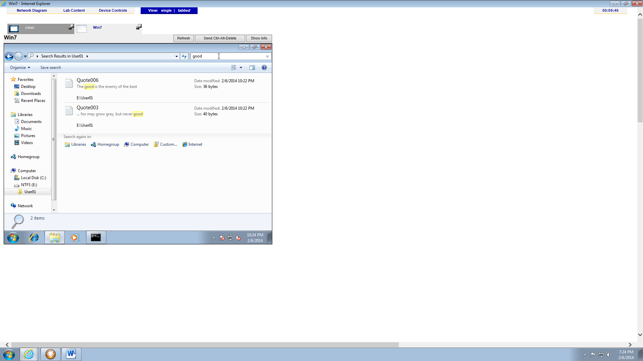

1. Activity 7-18, after #10 (8 points)

